CODE FOR1: -

const int sensorPin = 2;
const int greenLED = 8;
const int redLED = 9;
const unsigned long TIMEOUT = 3000;
void setup() {
pinMode(sensorPin, INPUT_PULLUP);
pinMode(greenLED, OUTPUT);
pinMode(redLED, OUTPUT);
Serial.begin(9600);
Serial.println("=== Sensor Timeout Simulation ===");
}
void loop() {
Serial.println();
Serial.println("Requesting Sensor Data...");
unsigned long startTime = millis();
bool sensorReceived = false;
while (millis() - startTime < TIMEOUT) {
if (digitalRead(sensorPin) == LOW) {
sensorReceived = true;
break;
}
}
if (sensorReceived) {

Serial.println("Sensor Response Received");
digitalWrite(greenLED, HIGH);
digitalWrite(redLED, LOW);
delay(1000);
digitalWrite(greenLED, LOW);
}
else {
Serial.println("ERROR : Sensor Communication Timeout");
digitalWrite(redLED, HIGH);
delay(1000);
digitalWrite(redLED, LOW);
}
delay(1000);
} SIMULATION :-
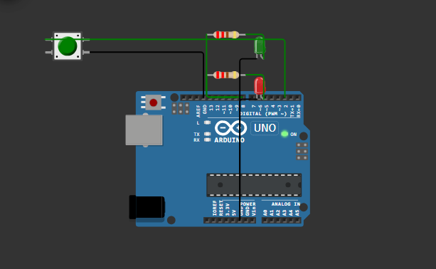

CODE FOR: - 2
#include <avr/io.h>
#include <avr/wdt.h>
const int GREEN_LED = 8;
const int RED_LED = 9;
unsigned long startTime;
bool failureTriggered = false;
void setup() {
// Disable Watchdog after reset
MCUSR = 0;
wdt_disable();
pinMode(GREEN_LED, OUTPUT);
pinMode(RED_LED, OUTPUT);
Serial.begin(9600);
Serial.println("--------------------------------");
Serial.println("Watchdog Timer Demonstration");
Serial.println("System Boot Successful");
Serial.println("--------------------------------");
delay(1000);
startTime = millis();
// Enable Watchdog (2-second timeout)
wdt_enable(WDTO_2S);
}
void loop() {
// Normal operation
digitalWrite(GREEN_LED, HIGH);
digitalWrite(RED_LED, LOW);
delay(300);

digitalWrite(GREEN_LED, LOW);
delay(300);
Serial.println("System Running...");
Serial.println("Watchdog Reset");
// Feed the Watchdog
wdt_reset();
// Simulate failure after 10 seconds
if ((millis() - startTime > 10000) && !failureTriggered) {
failureTriggered = true;
Serial.println("");
Serial.println("***********************************");
Serial.println("ERROR DETECTED!");
Serial.println("Sensor Communication Failure");
Serial.println("CPU HANG SIMULATED");
Serial.println("Watchdog will reset the system...");
Serial.println("***********************************");
digitalWrite(GREEN_LED, LOW);
digitalWrite(RED_LED, HIGH);
// No watchdog reset during this delay.
// Since watchdog timeout = 2 seconds,
// Arduino will automatically restart.
delay(5000);
}
}
SIMULATION :-
